

MARMARA UNIVERSITY
FACULTY OF ENGINEERING
PHYS 1103.4
PHYSICS LABORATORY

EXPERIMENT 6

ATWOOD’S MACHINE
Section Number: 7
Group Number: 8
Submitted to: Arş. Göv. Hüseyin YALTIRIK
Due Date: 28.12.2021

 | Dept | Student Id | Name Surname | Contribution
1 | EE | 150720062 | MEHMET ALİ KAMALAK | Conclusion, theory, references, purpose, calculations,questions

CONTENTS

Purpose: 3
THEORY : 3
CALCULATION : 3
Mass A: 3
CONCLUSION : 6
QUESTIONS : 6
REFERENCES : 7

Purpose:
In this experiment, I use objects that have different mass and plunk. I recording the video to this system. After, I uploaded tracker to that my recording video.

THEORY:
I made a pulley system using a pulley and objects of two different masses. I videotaped this and uploaded this video to tracker. In this way, I found the x-t graph, the acceleration value.

CALCULATION:

Mass A:

t(s) | y(m)
0 | -0,428
0,05 | -0,424
0,1 | -0,43
0,15 | -0,413
0,2 | -0,406
0,25 | -0,398
0,3 | -0,392
0,35 | -0,385
0,4 | -0,377
0,45 | -0,366
0,5 | -0,364
0,55 | -0,347
0,6 | -0,336
0,65 | -0,323
0,7 | -0,312
0,75 | -0,306
0,8 | -0,295
0,85 | -0,283
0,9 | -0,276
0,95 | -0,257
1 | -0,248

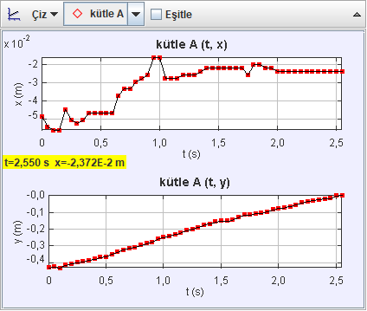

Mass B:

t(s) | y(m)
0 | -0,435
0,05 | -0,441
0,1 | -0,444
0,15 | -0,453
0,2 | -0,456
0,25 | -0,462
0,3 | -0,474
0,35 | -0,48
0,4 | -0,483
0,45 | -0,492
0,5 | -0,501
0,55 | -0,515
0,6 | -0,521
0,65 | -0,536
0,7 | -0,539
0,75 | -0,56
0,8 | -0,569
0,85 | -0,581
0,9 | -0,59
0,95 | -0,602
1 | -0,607

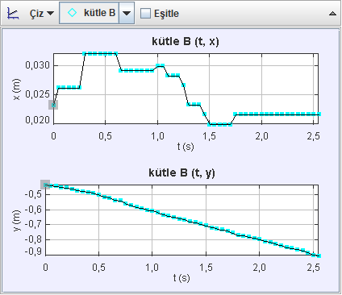

DOT NUMBER | MEASURED |  |  |  | EXPERIMENTAL
DOT NUMBER | POSITION |  | TIME | SQUARE OF TIME | SLOPE
DOT NUMBER | Mass,m(A) | Mass,m(B) | TIME | SQUARE OF TIME | SLOPE
DOT NUMBER | y(m) | y(m) | t(sec) | t^2(s^2) | s(m/s^2)
0 | 0 | 0 | 0 | 0 | -2,4
1 | -0,43 | -0,444 | 0,1 | 0,01 | -2,4
2 | -0,392 | -0,474 | 0,3 | 0,09 | -2,4
3 | -0,364 | -0,501 | 0,5 | 0,25 | -2,4
4 | -0,312 | -0,539 | 0,7 | 0,49 | -2,4
5 | -0,276 | -0,59 | 0,9 | 0,81 | -2,4

CONCLUSION :
When I was in the same system, I learned that the accelerations of objects with two different masses are the same. I also learned that if the net force remains constant, the acceleration decreases as the total mass increases.

QUESTIONS :

1 An Atwood's Machine is a simple device consisting of a pulley, with two masses connected by a string that runs over the pulley. Net force which causes and acceleration of the system is difference between the weights of the objects.
2 We can see that constant acceleration, if we divide the interval by the square of the second.
3 We can find the acceleration value by dividing the distances they take per unit time by the square of the second.
4 When F=m.a, total mass and acceleration are inversely proportional. That’s why we increase or decrease at the same rate net force is not change. But acceleration and mass is change.
5 If the net force due to mass difference remains constant but the total mass increases, acceleration is decreases. Because total mass and acceleration are inversely proportional and when net force is constant, acceleration is decreases.

6 Each mass in the same system. So accelerations are joint and equal to each other.

7 Yes, it is.

REFERENCES:
Edmodo experiment 6 pdf

